Lefebvre Nelson
03137910
Ai Reading 1

First of all, in France I already had a course about artificial intelligence and so I knew the aspect of the different kind of intelligence that we can program. But where the text surprised me and where I questioned myself on my knowledge is on the fact of asking questions which are rather general on the artificial intelligence and that many concepts which are approached by the man are not yet solved. Let me explain.

The interlocutor asks him the question ‘ when does the research on the articial inteligence exists? ’ and this one explains to him that that goes back to after the WWII, and that numerous researcher as Alan turing one made prototype being able to approach artificial intelligence. What temporally for the computer science is very old! But it is still difficult to associate our intelligence to the methods used to solve problems in computing. I am thinking in particular of the question "Is AI intended to put the human mind into the computer? ". We have seen that AIs are capable of being gifted in multiple domains (pattern recognition, search, planning etc..), but that they are not as complex and versatile as ours. They can always try to copy us but will always have a lack of naturalness that we would find in humans. For example according to my knowledge that I acquired, the man realizes errors which are voluntary and which can sometimes make of intelligence and that the machines have difficulty to realize. Let's take the example of the perlin noise, it's a procedural texture used as a visual effect to increase the apparent realism in the image synthesis. It is a way to give the illusion to a rendering that it is fluid for us. But this is far from reality, it just gives the illusion of a natural rendering. Well, it's the same for technology. I think the real challenge of tomorrow is to be able to teach and make AIs able to reason from raw knowledge.

And I think we are on the right way. Even if there is still a lot of work to do. In particular with the advances made in deep-learning. Who approaches problems in a more natural way as a human being could. And so what's interesting is that even though it's one of the pillars of computing there's still a lot to discover.

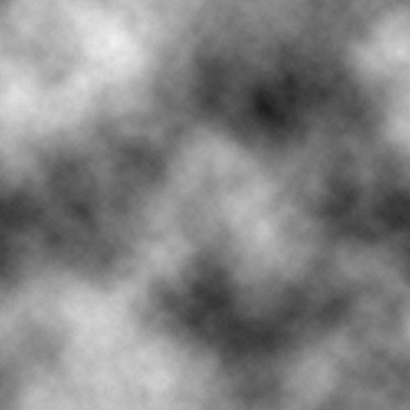
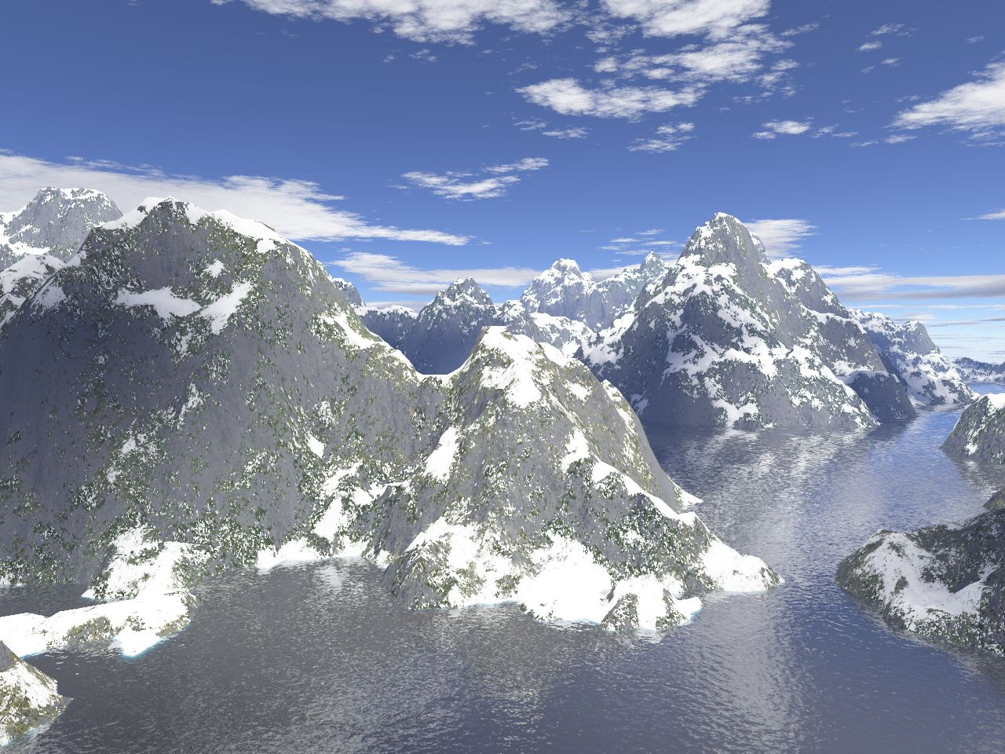

Perlin noise Generated Perlin noise map

